Technical assessment - Rocket.Chat Enterprise Solutions team - Technical Support Analyst position - Marina Santos

link to my Rocket.Chat setup: https://b485f6511d8b.ngrok.io/

user: marvandort

password: Atena123

**Install and setup my Rocket.Chat**

For the installation and configuration of the server I used Virtual Box machine running Ubuntu 20.04.1

I used the documentation available at the link <https://docs.rocket.chat/installation/snaps> to configure and install the server, using the aid of Snaps. The process was quick and practical.

After completing a server configuration I pointed my localhost to port 3000 and entered the Rocket page to finish registering my account. I registered the login and followed all the necessary steps to finish creating the account

As it was pointing only at my machine I used Ngrok to create a connection, so you can have access to the server too. Ngrok maps the localhost, pointing to the set port and allowing access via an external network.

I performed tests on my machine, they worked normally.

Below are all screenshots showing all the steps mentioned above.

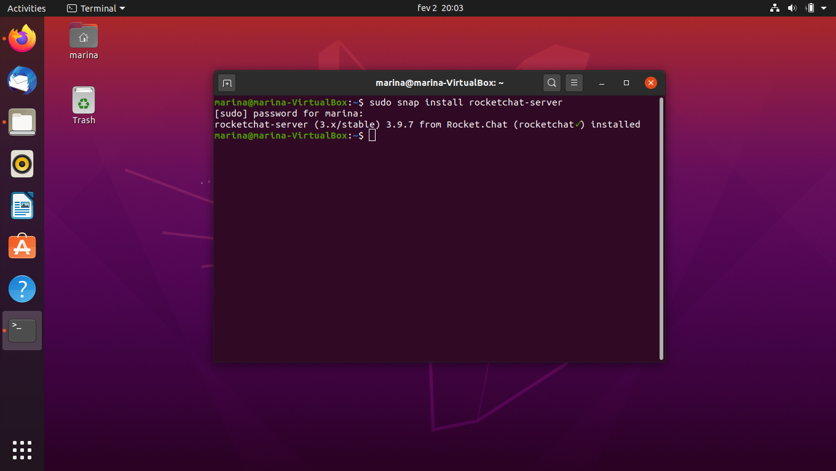

Terminal Rocket.Chat Server installation

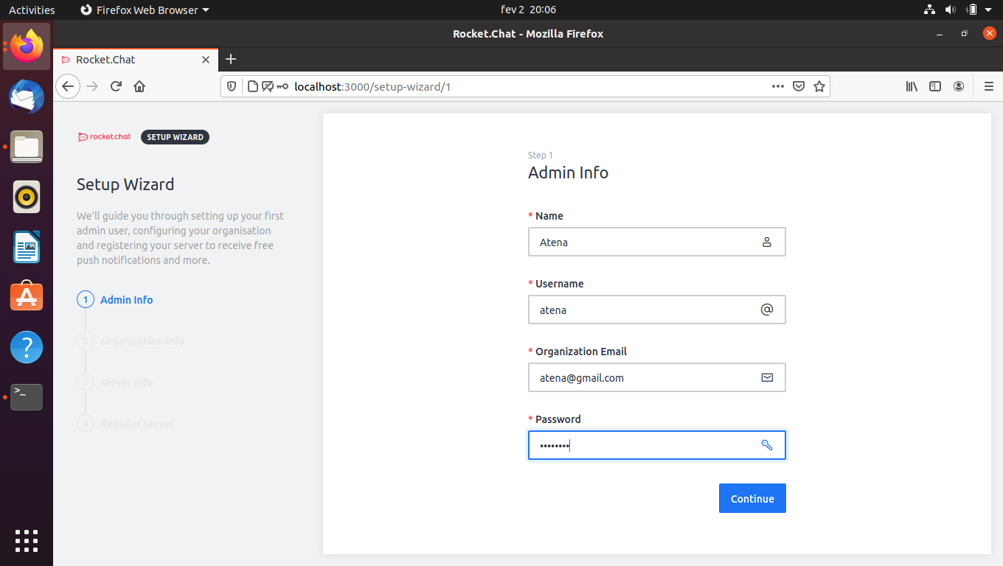



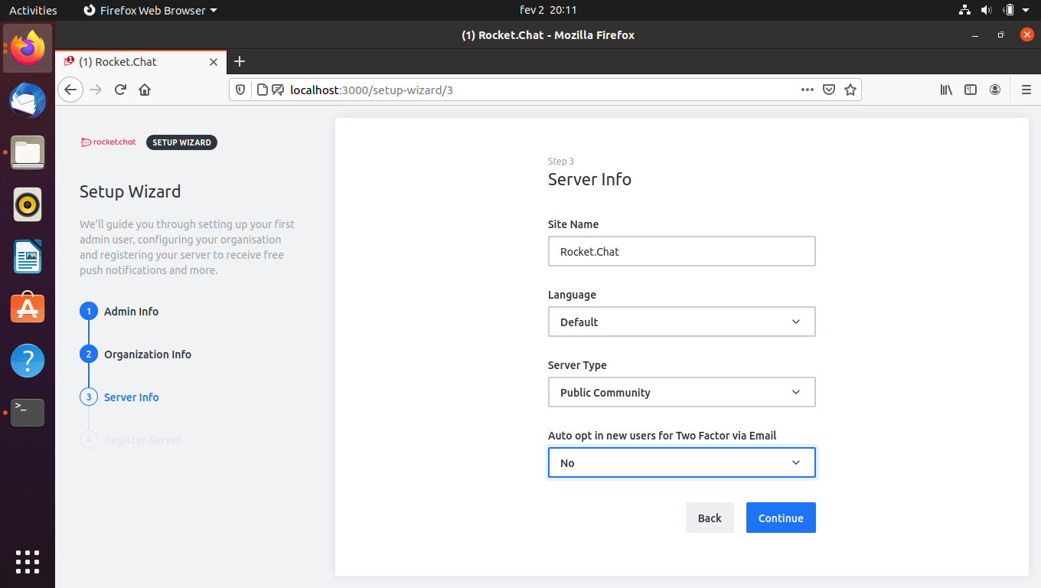

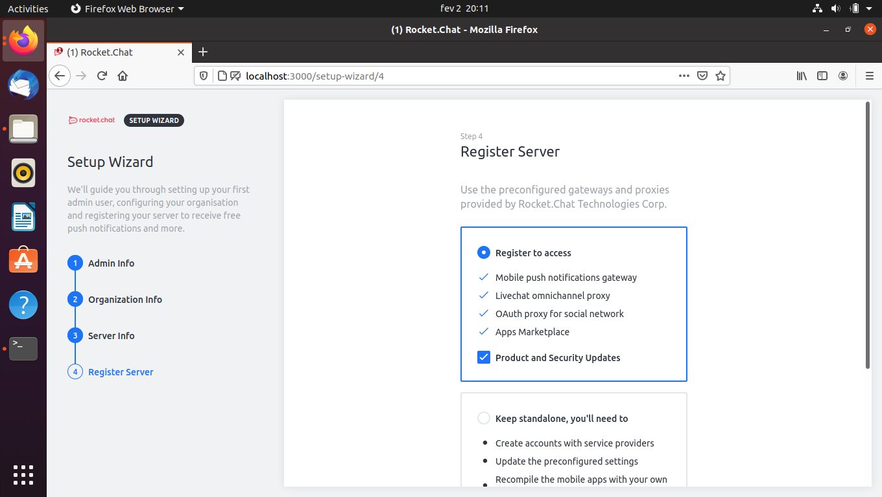

Account Created

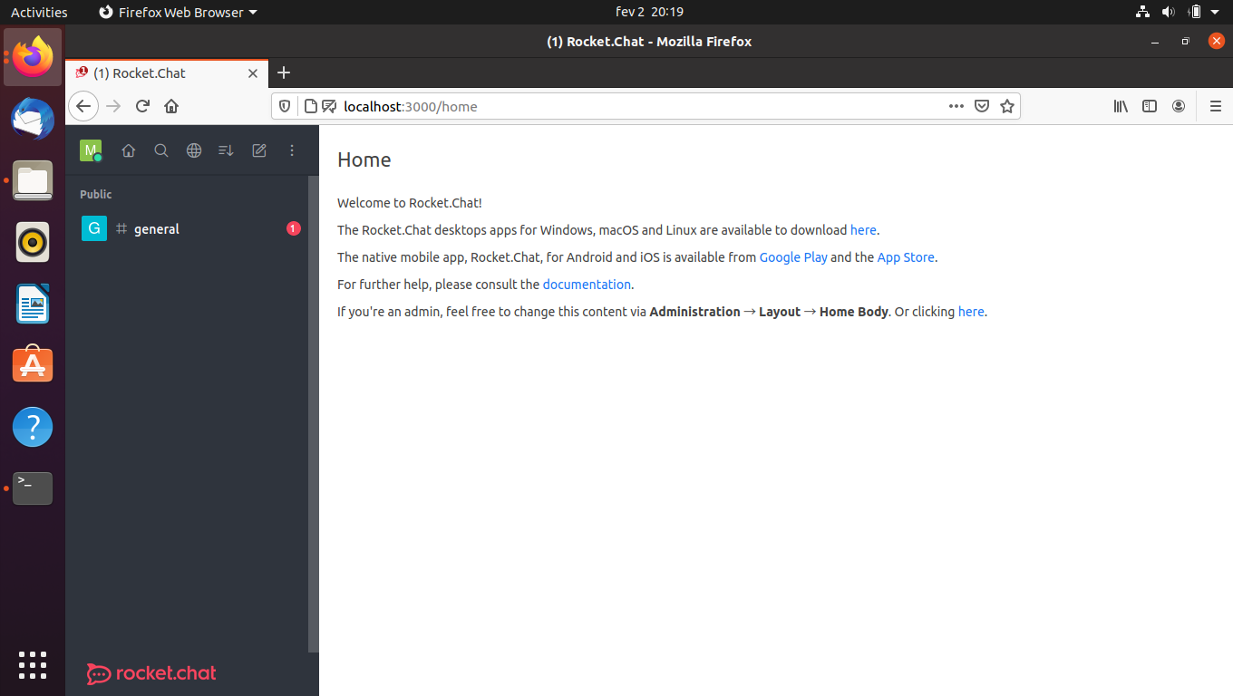

rocket.chat server home page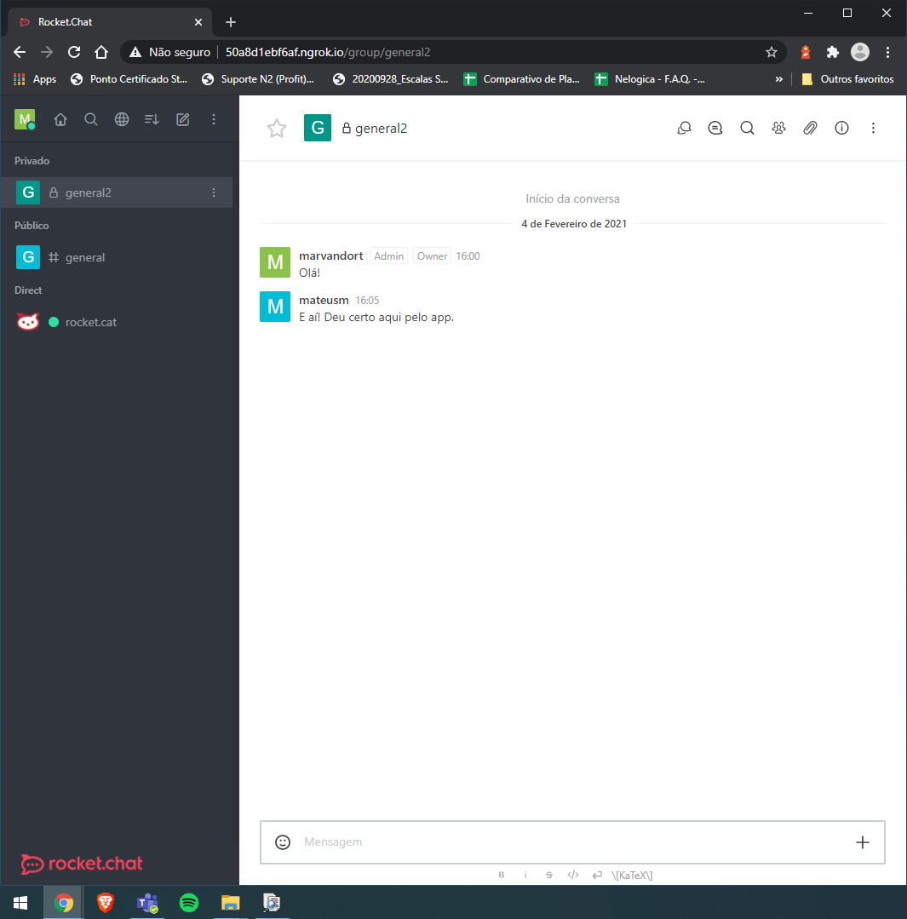

testing server access via external network

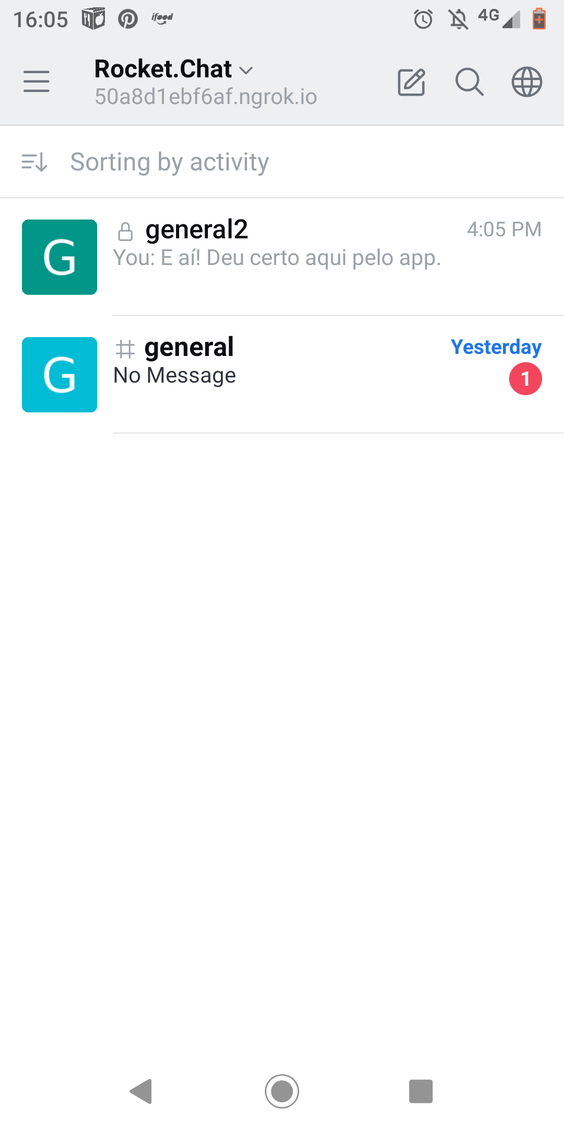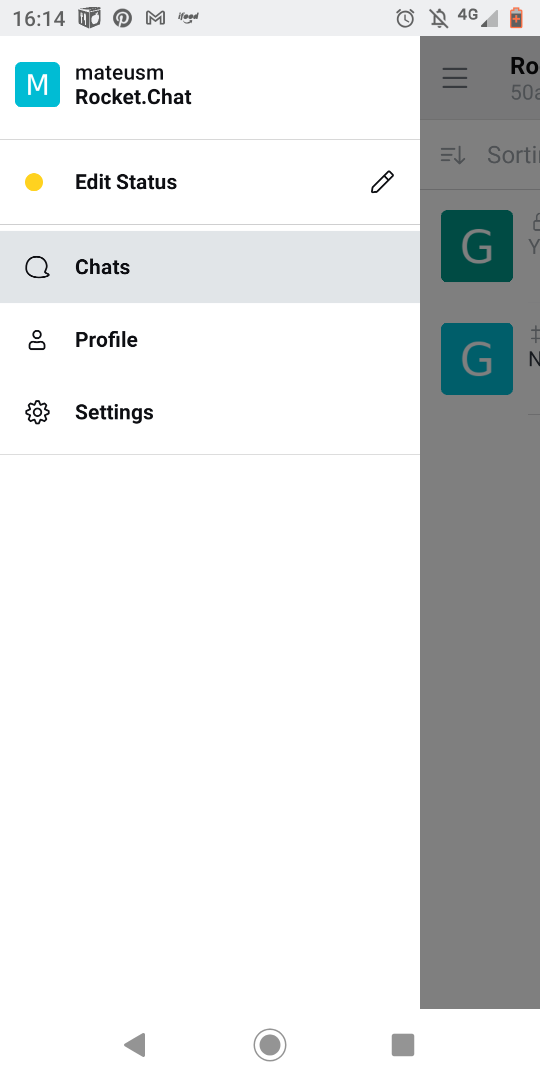

testing access via mobile app with the server link. I used the user data created in the API

**API’s**

I did all the chores using the Ubutu Terminal, all the tests were OK and return what it was asked. I’d try to used the Postman at first, but it presented some errors and I ended up opting for the terminal.

Server Login 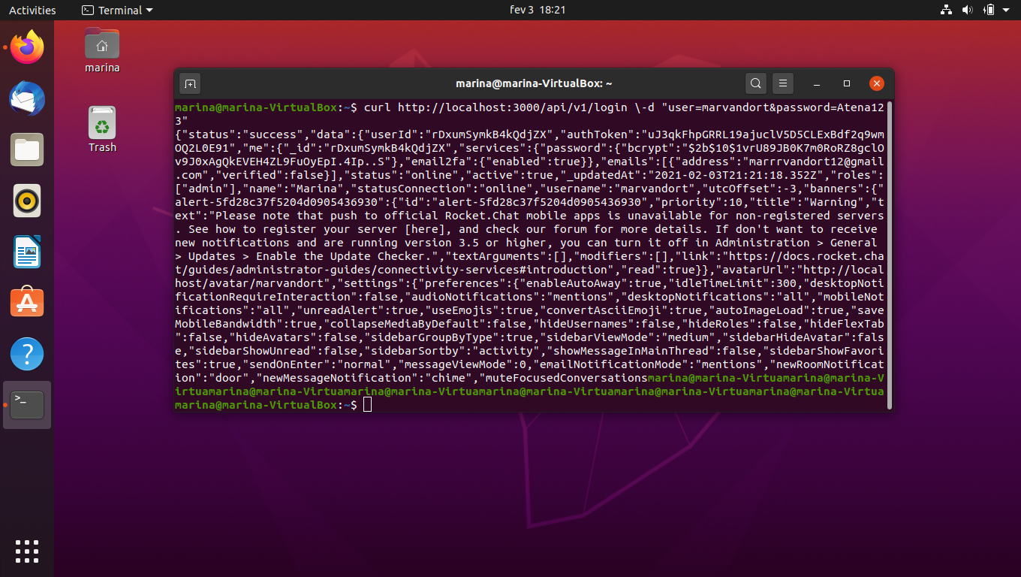

**Task 1 - User creation**

With the commands available in the API's docs I created the user "mateusm", first directing my Authtoken and userID.

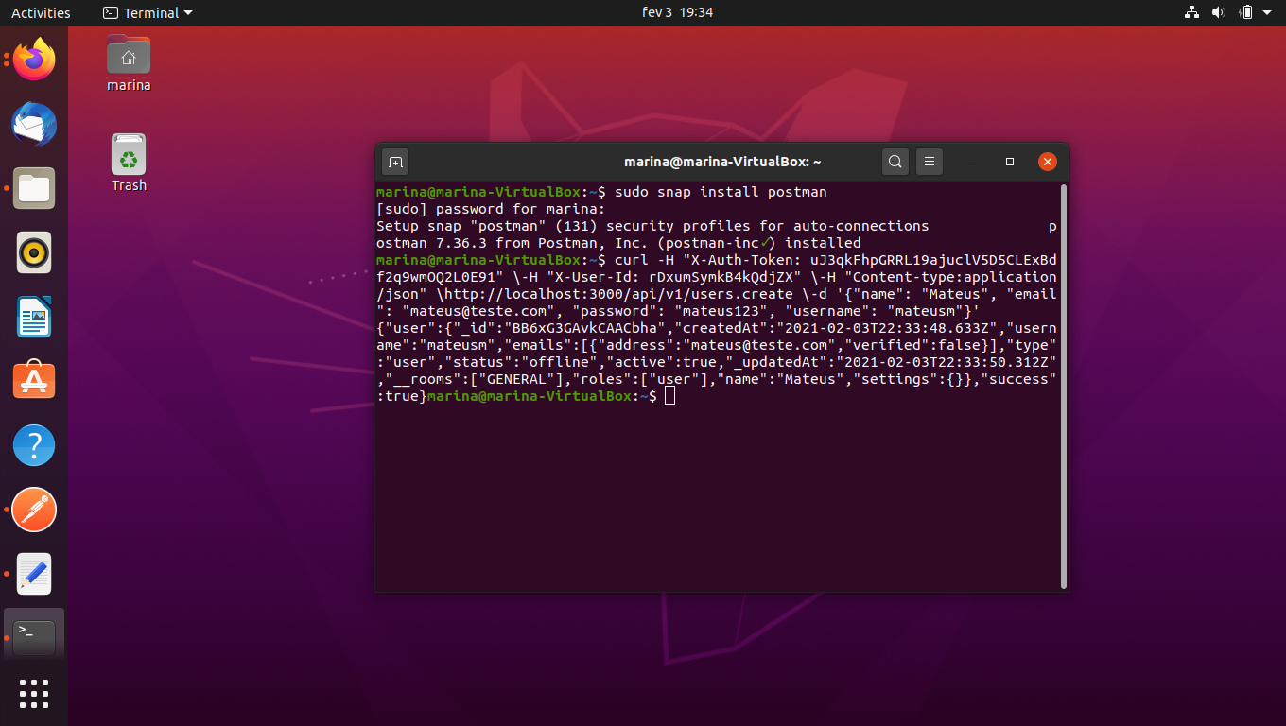Terminal users.create and response.

**Task 2 - Get the Room information**

The same server and ID parameters were kept, and I used the command rooms.get that is also available in the docs.

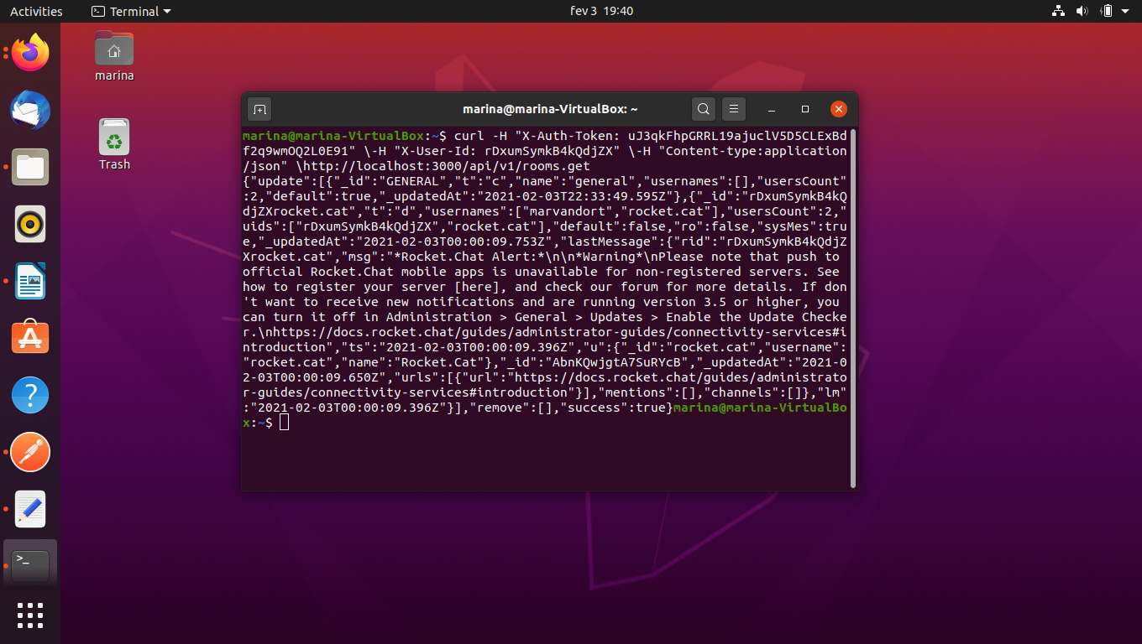

Terminal rooms.get and response

**Task 3 - Get a list of all user roles in the system**

For this task only the parameters ID and Authtoken are required. The command to request the list on localhost was roles.list.

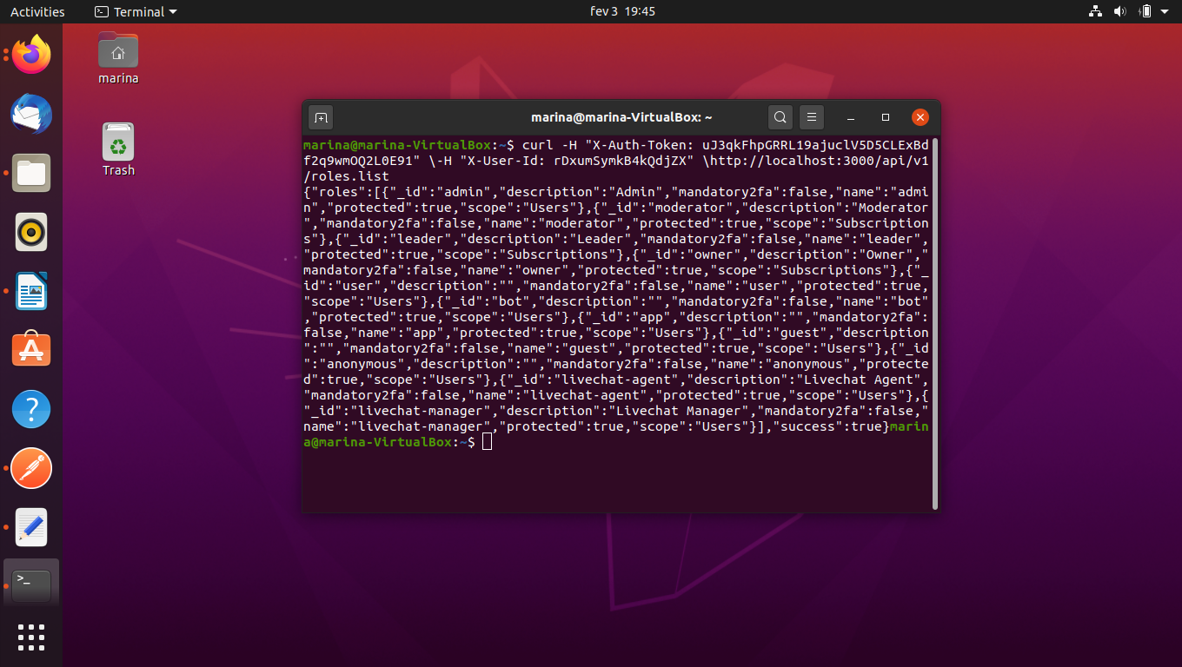

Terminal roles.list and response